Warren Alliance - First Church of the Nazarene - First Church of God

MEGA SPORTS CAMP
Ages 4-5 and K-5th Grade
JUNE 22-25 (6 pm - 8:30 pm)
At the Warren Alliance Church (814)723-2380


278 KINZUA RD. WARREN PA


NEW SPORT Cycling Cheerleading Soccer
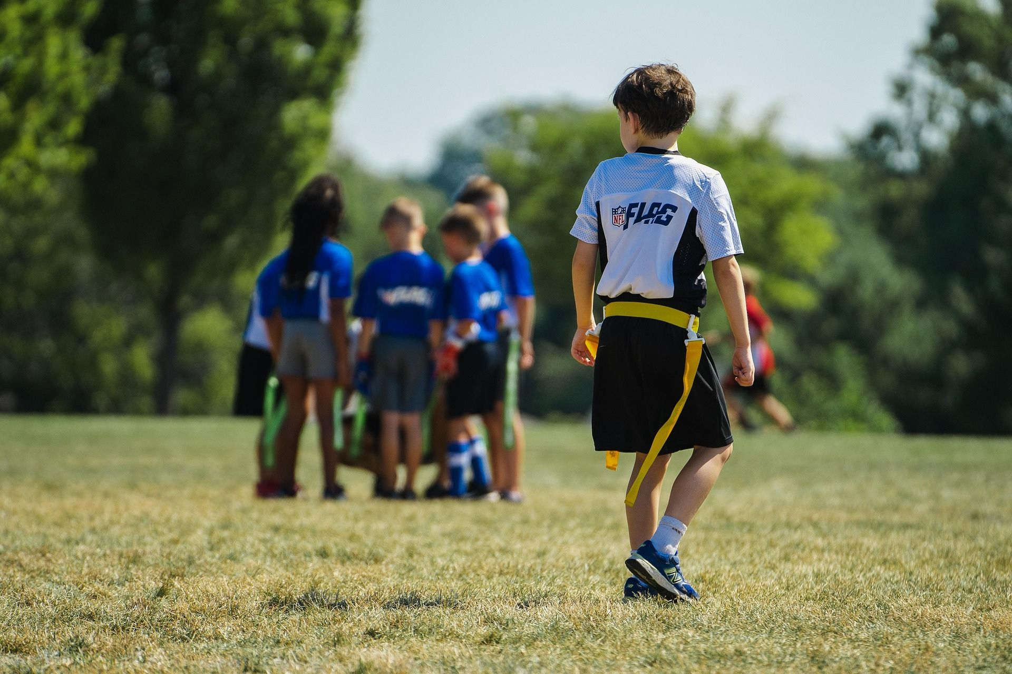



Flag Football Basics Ages 4-5 Register Now

Including “Family Fun Night” June 25th
flag football, basketball, soccer, four Square in the air, dunking booth, scooters, water balloon launcher, cornhole, kickball, gaga ball, chalk, bubbles, etc. Food: hot dogs, chips, drink, S’mores

